**Ouput**:

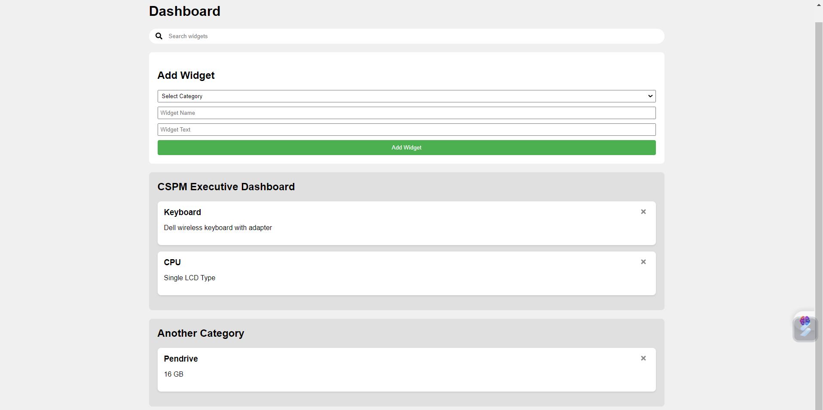

Click to view screen recording:

https://www.loom.com/share/434394a52eb74a6b892182feb54c85f8?sid=6dc05209-7893-4df4-8f8e-7e548ad2815a